To: Association of Vermont of Conversation Commissions

From: Andrew Graminski, Town of Brattleboro Planning Services Department

RE: 2019 AVCC Tiny Grant Success Story

Date:

Dear Members of the AVCC,

The Brattleboro Conservation Commission was awarded the 2019 AVCC Tiny Grant for the purposes to help eradicate the invasive Japanese knotweed from portions of West River Park. With assistance from Tiny Grant Program, the Brattleboro Conservation Commission was able continue with a second season of managing Japanese knotweed along the banks of the West River in the West River Park. The funding allowed the Conservation Commission to purchase loppers, pruners, tarps and work gloves so that community volunteers could help steward the site. Several work sessions were held during the of summer 2019. The funding also helped the Town create lawn signs to raise awareness about Japanese knotweed. These signs can be found at sites where people are actively managing the invasive species as well as on public land that has Japanese knotweed.

The commission was successful with managing Japanese knotweed in the park. It was estimated that the Commission, with the help of public volunteers, was able to remove over 50,000 square feet of knotweed during the 2019 field season (May – September). The Commission was able to keep a 100-foot stretch of knotweed under control on one side of the West River. Though knotweed is still present at the park, efforts to control it are still happening and tools purchased using the AVCC grant money has helped get more people involved and keep the knotweed under control so that the public can enjoy access to the river for recreation.

Best regards,

Brattleboro Planning Services Department

Brattleboro Conservation Commission

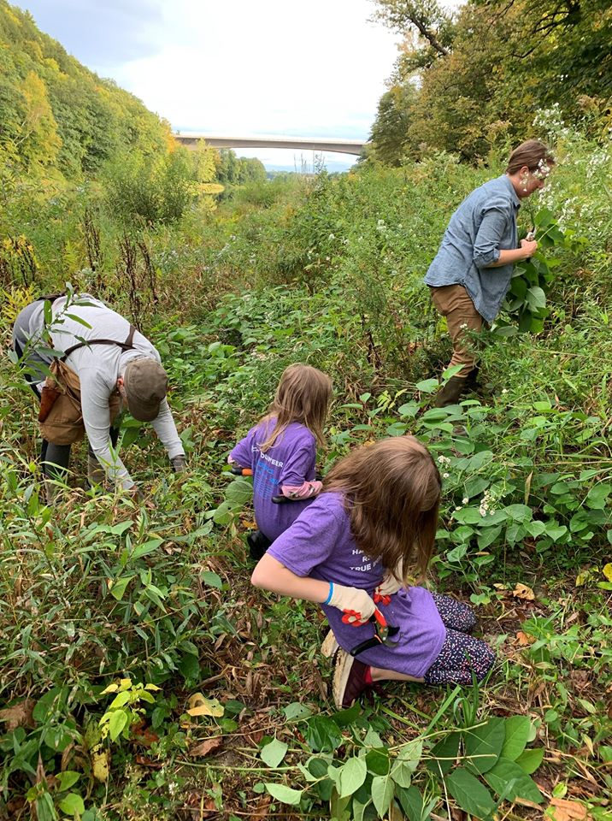Photo